ATTENTION: Application form must be filled in by computer. Handwritten or uncompleted requests will not be accepted.

All the requested documents and information must be sent in just one mail. Incomplete solicitudes will not be treated.

Pay attention for both of the accompanist gaps in the application form (trustee and pianist). In case that your trustee is also your pianist, please, indicate it.

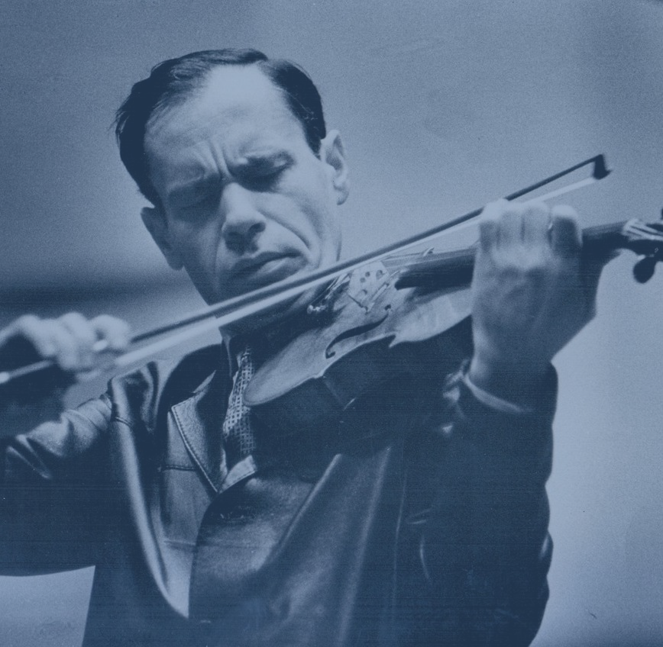 | Leonid Kogan International Competition for Young Violinists, Brussels
Application form
I. Basic Information
Last Name |  |  | First Name
Middle Name (If any) |  |  | Gender
Date of Birth |  |  | Nationality
ID Number |  |  | Passport Number
E-mail |  |  | Contact Number
Postal Address
II. Emergency Contact
Last Name |  |  | First Name
Relationship to You |  |  | Contact Number
III. Musical Background (Including Masterclass)
Period of Time
Tutor
Name of Institute / Venue
IV. Awards（Optional）
Prize
Name of Competition
Venue
VI. Accompanist（Optional）
Last Name |  |  | First Name
Middle Name(If any) |  |  | Gender
Date of Birth |  |  | Nationality
ID Number |  |  | Passport Number
E-mail |  |  | Contact Number
Postal Address
VII. Chosen Program
Category 1 and 2
Category 3 and 4
Preliminary round
Category 3 and 4
Final round
VIII. Documents (Please attach the documents with the Application Form )
Biography
Photo
ID Card /Passport
Diploma Certificate
Award Certificate （Optional）
IX. Statement
I herewith apply to participate in the Leonid Kogan International Competition for Young Violinists 2018, Brussels. I have read the Apply Regulation and Rules of the Competition and I agree to abide by them. I hereby agree to have my profile and image(s) processed in all information and promotional materials associated with the Competition.
---------------------------  Date |  | ---------------------------  Signature of Applicant

